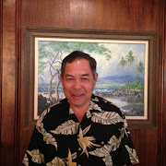

About Us

Hawaii Water and Drainage, LLC was established on April 1, 2013 with a vision to be a premier Hawaii manufacturers’ representative of storm water drainage, water distribution and waste water conveyance products and technologies.

Education: Roosevelt High School graduated 1971

University of Hawaii BBA graduated 1975

Membership: Member of American Water Works Association

Board Member of Hawaii ABPA

Past Member WEFTEC

Member of Oahu Country Club since 1984

Member of YMCA

Office Manager of John Craft Painting Company 1975

Industrial Coating Salesperson of Pacific Industrial Distributors 1983

Salesperson of PRYCO, Inc. 1987

Salesperson of Architectural and Engineering Systems 1995

Manager of WAI Utilities 2001

Manager of Delco Sales 2006

President of Hawaii Water and Drainage, LLC 2013